1. Here look a little more at the effect of sample size on fitting regression models. Use

the R program **RegressionBiasVarianceHighBias.R** to do the following. This code

produces the two plots as seen in Figure 4 when all the code is run. You do not need

to understand how the program works or rewrite any code. A few lines from the top

is a line that says “n = 10”, which controls the sample size. We saw plots for *n* = 10

and *n* = 100 above.

(a) Change *n* to be 25 and rerun the entire code. Report these figures. Focusing on

the bottom left plots, which model seems to get closer to the true structure across

the whole range of *X*: the linear or the 4th-order polynomial?

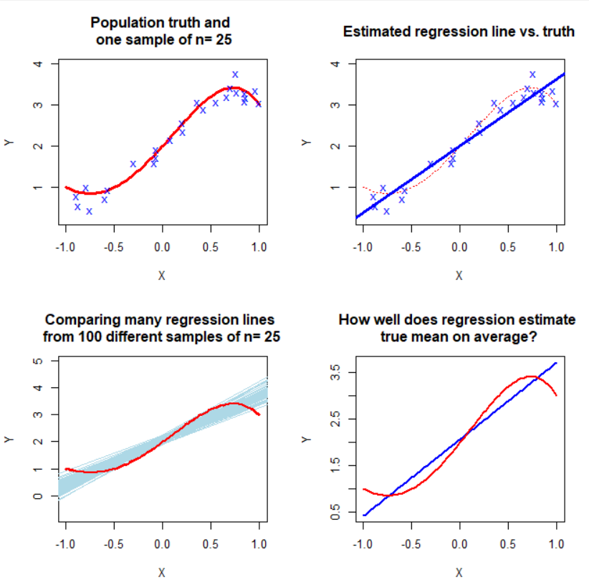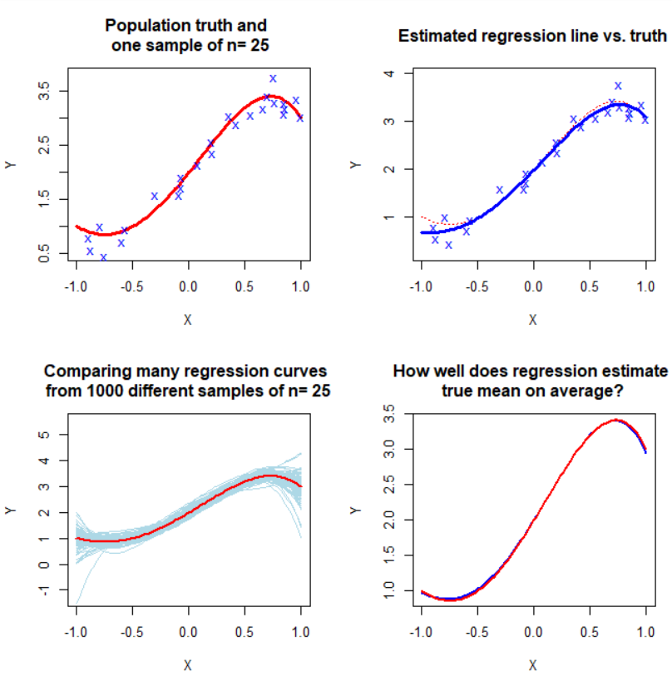

* the 4th-order polynomial fits better than linear.

(b) Repeat for *n* = 50, reporting the figures and commenting on how the bottom left

plots change.

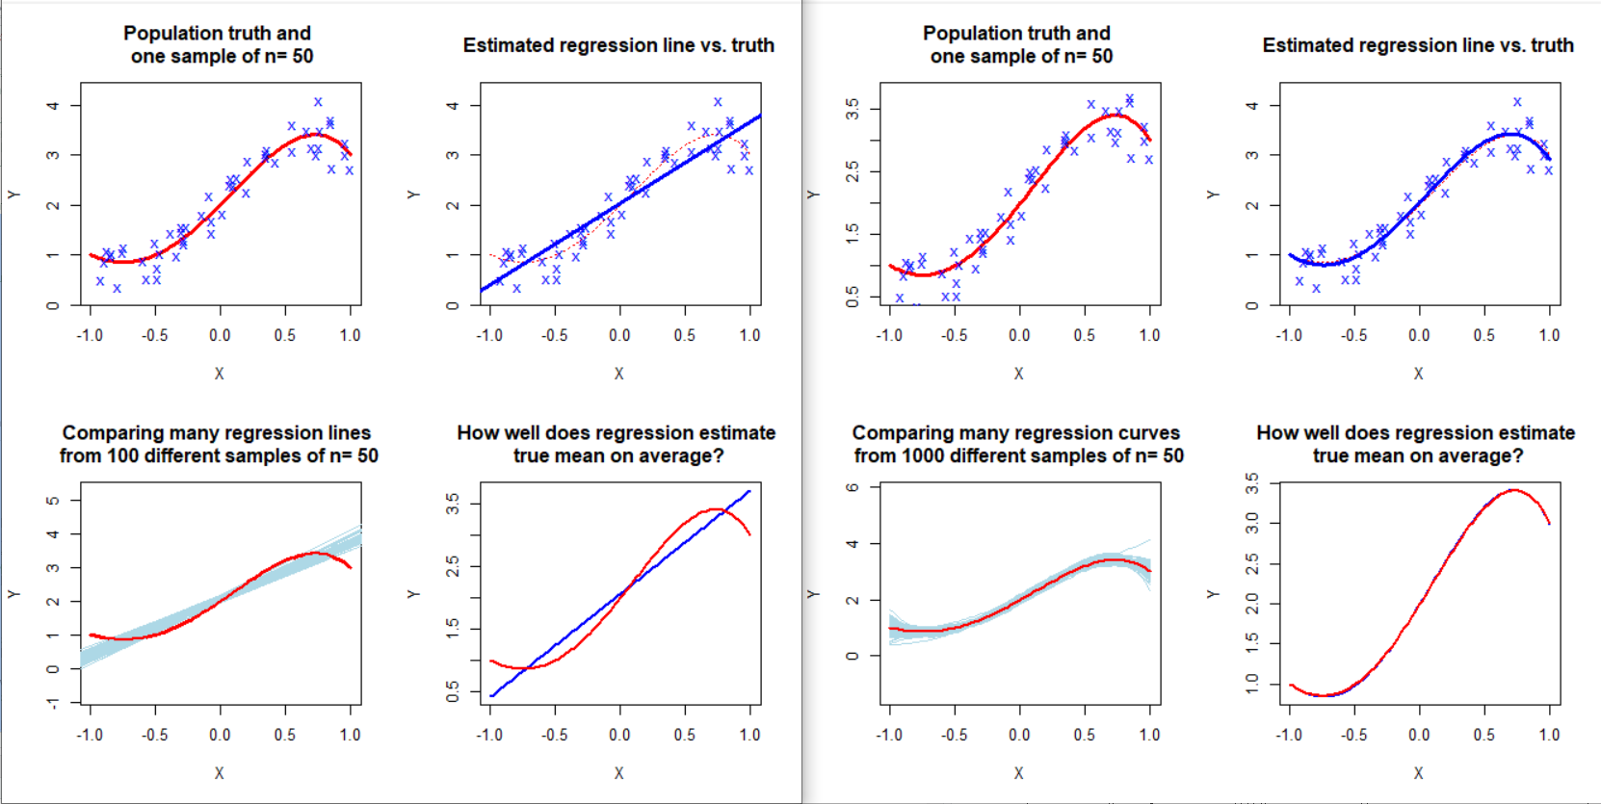

* The blue lines get slimmer compare to blue lines from n=25, and also blue lines in 4th order polynomial get closer to population.